**YOLOv3- Crack Detection**

What is YOLO?

* You Only Look Once- Real time object detection- 45fps
* Reframes object detection as a single regression problem.
* So instead of having several neural networks interconnected with each other, there is just one model which does all the work- classification, localization, detection, and segmentation.
* The model has just 24 convolutional layers followed by 2 FC layers.
* The single CNN predicts bounding boxes and class probabilities for those boxes.
* It divides the image into an S × S grid and for each grid cell predicts B bounding boxes, confidence for those boxes, and C class probabilities. These predictions are encoded as an S × S × (B ∗ 5 + C) tensor.

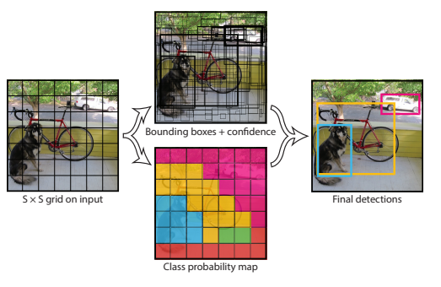

At test time, each grid cell predicts B bounding boxes and confidence scores for those boxes. These confidence scores reflect how confident the model is that the box contains an object and also how accurate it thinks the box is that it predicts.

Here are some of the outputs I got after training on the images in the ‘train’ folder of our dataset.

Trained for 2000 epochs. (Recommended number of epochs = 2k*number of classes)

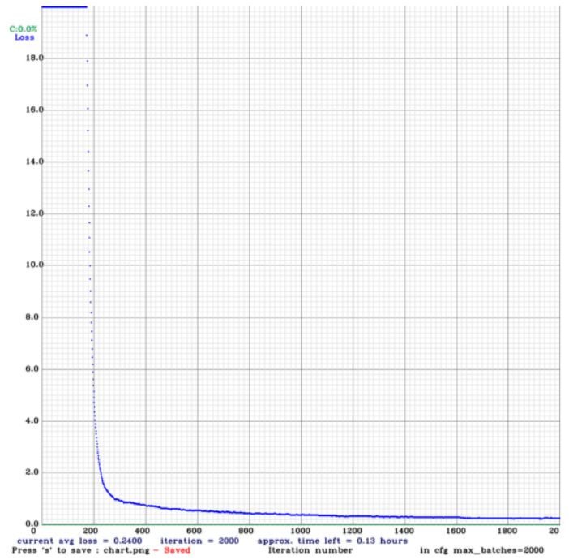

The pink rectangle is the predicted bounding box. At the top left, the predicted class along with the confidence score is given.

For each set of 3 images in the following pages, the 1st image is the YOLO prediction, the second image is the actual bounding box and the 3rd image is the mask.

**YOLOv3 on 2000 Epochs**

Rissbilder_for_Florian_9S6A2822_1030_155_3516_3590.jpg

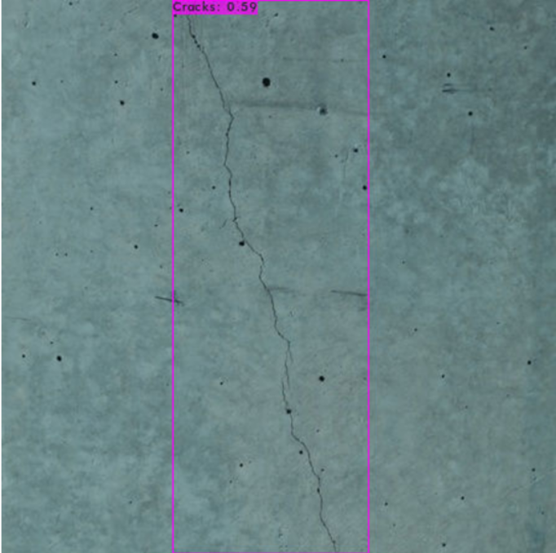

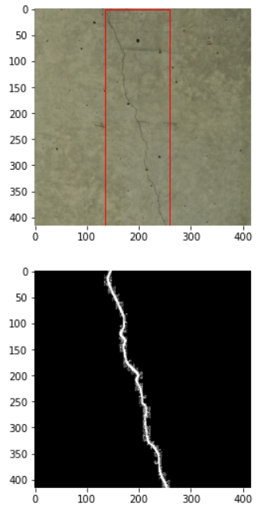

noncrack_noncrack_concrete_wall_65_0.jpg.jpg

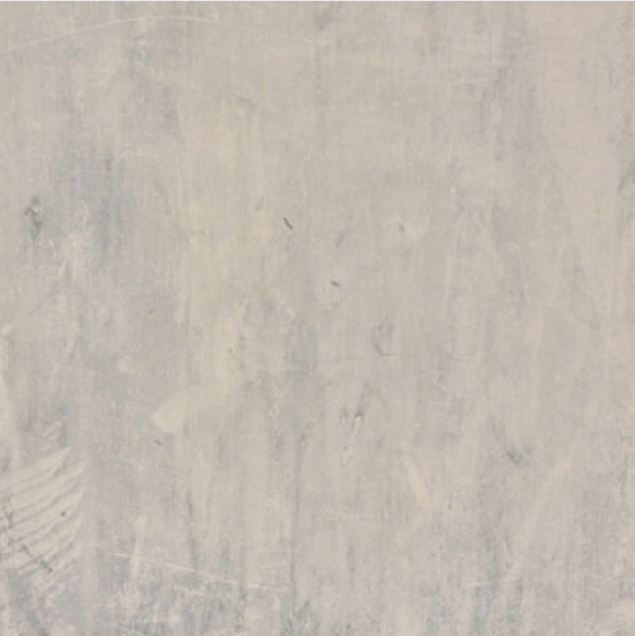

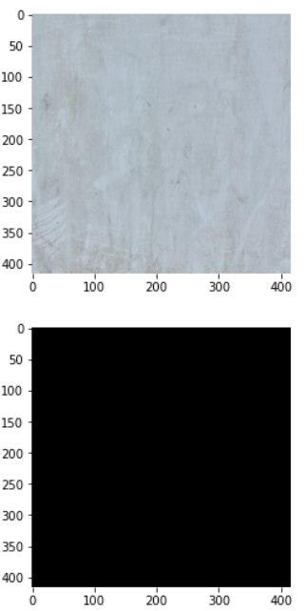

Rissbilder_for_Florian_9S6A2859_2073_725_3430_2687.jpg

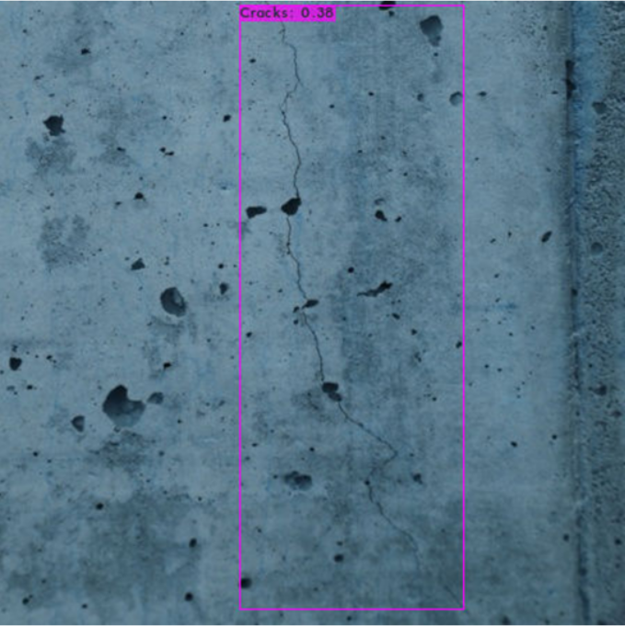

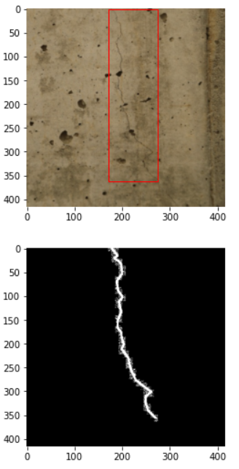

Rissbilder_for_Florian_9S6A2861_716_324_2856_3710.jpg

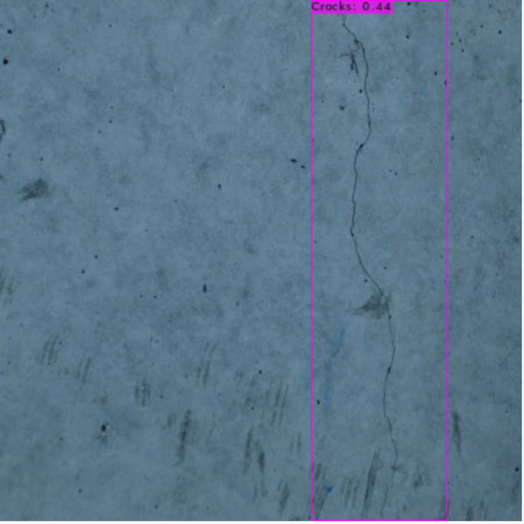

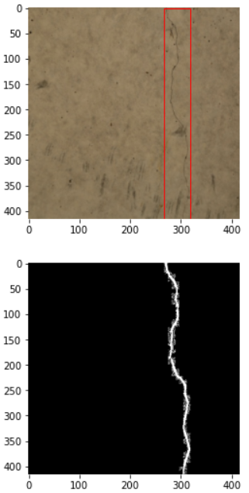

DeepCrack_11188.jpg

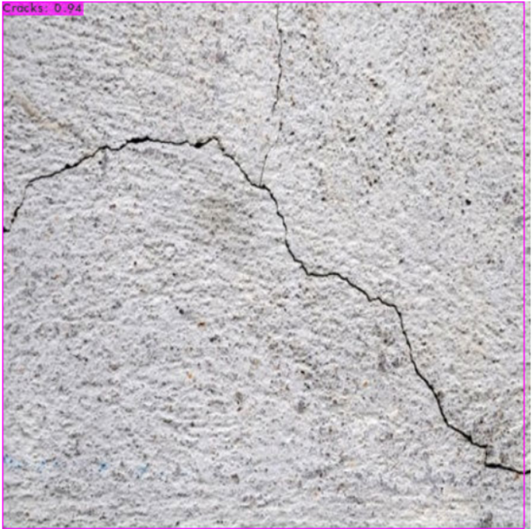

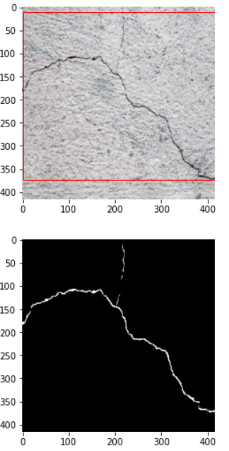

CRACK500_20160328_152308_1_361.jpg

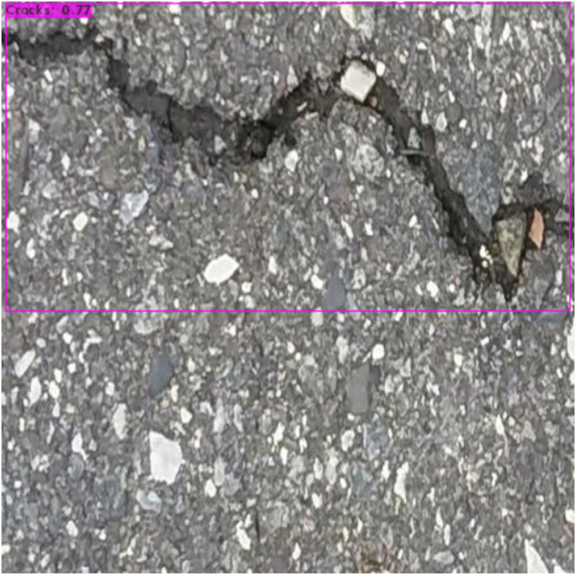

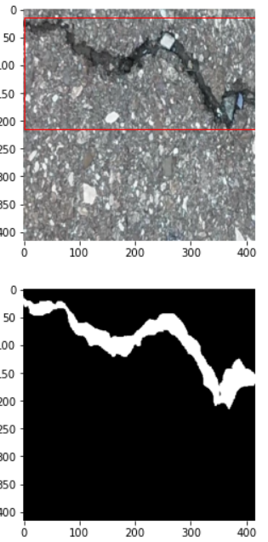

GAPS384_train_1015_1_641.jpg

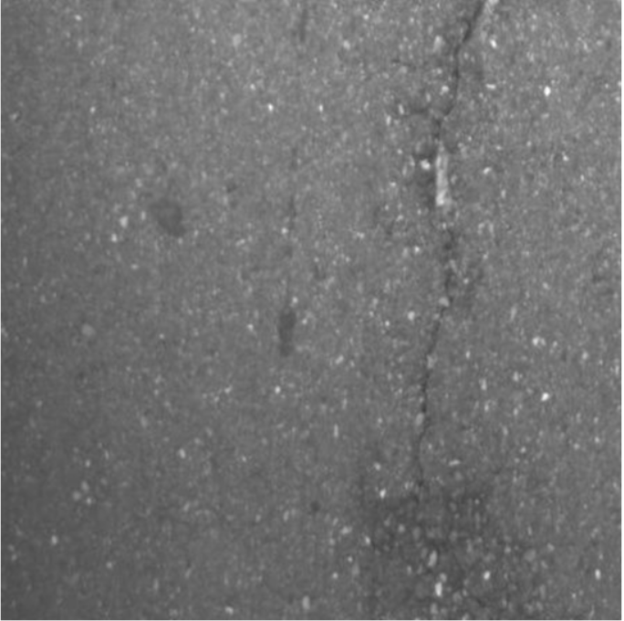

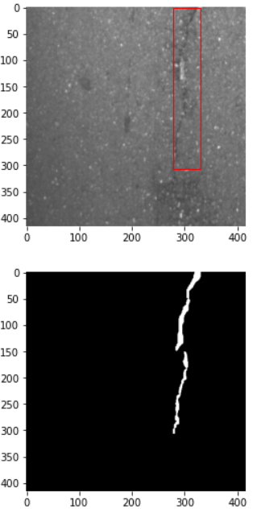

Sylvie_Chambon_039.jpg

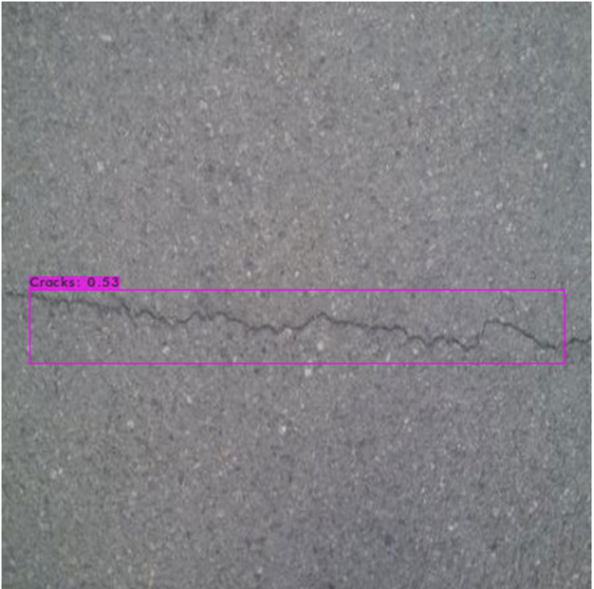

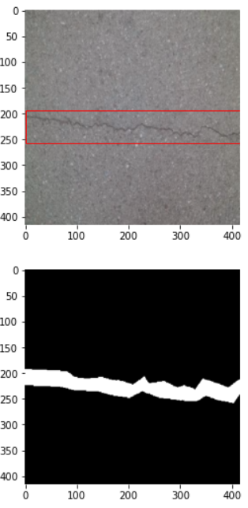

Volker_DSC01703_23_907_1787_1745.jpg

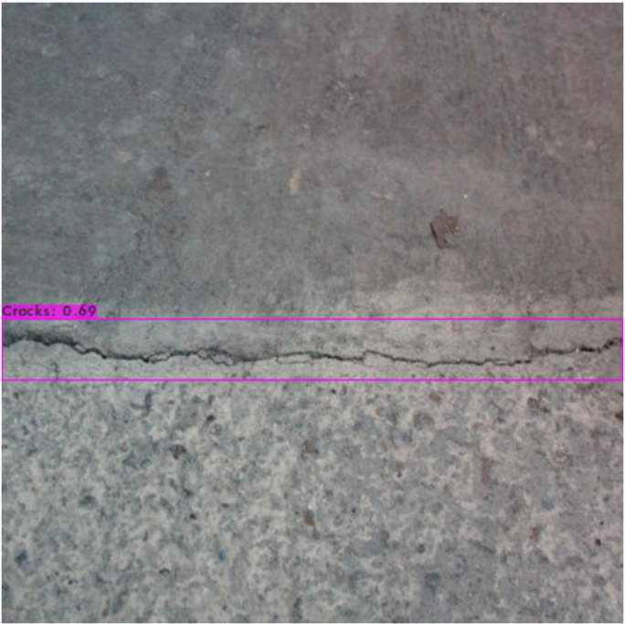

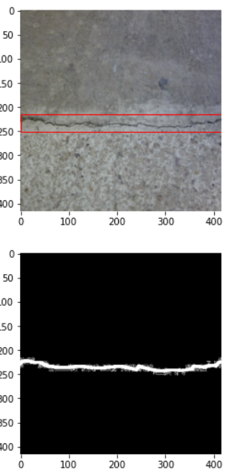

CRACK500_20160326_142309_1281_721.jpg

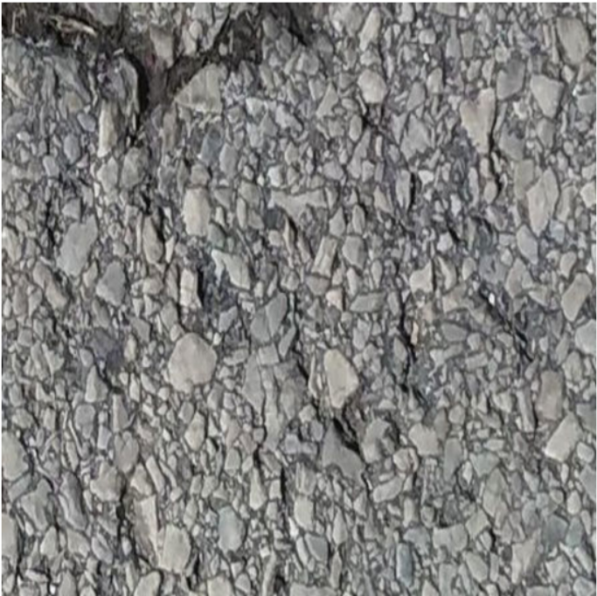

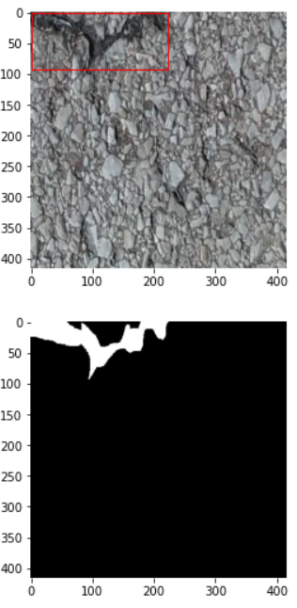

**YOLOv3 on 4000 Epochs**

1. Sylvie_Chambon_056.jpg- confidence = 0.48

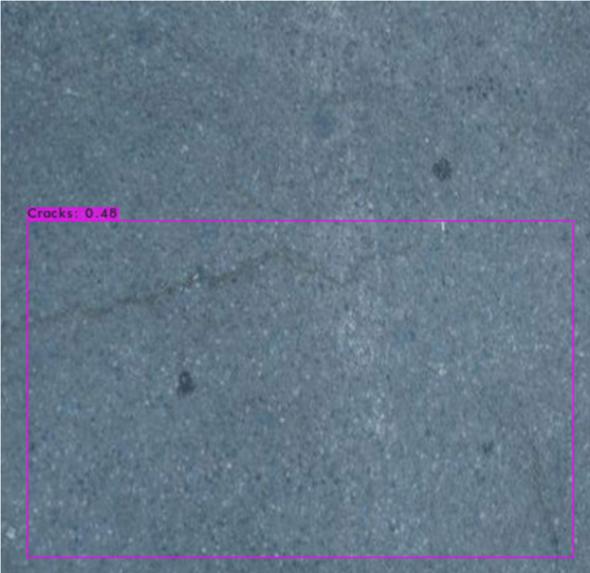

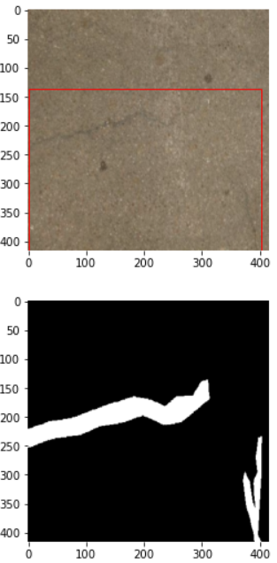

1. Eugen_Muller_9360_99_556_518_594.jpg- confidence = 0.81

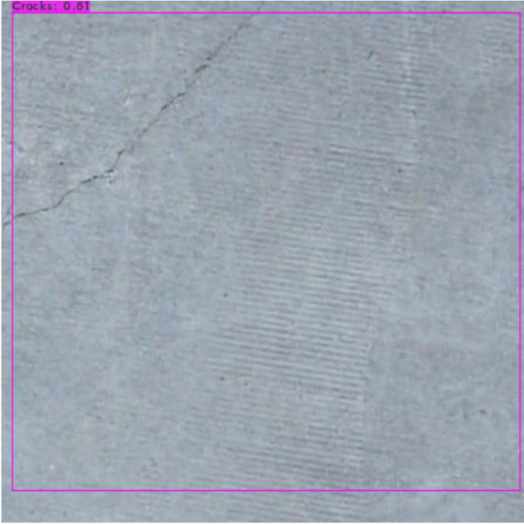

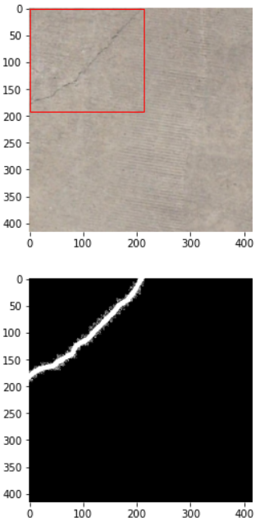

1. **DeepCrack_11155.jpg**

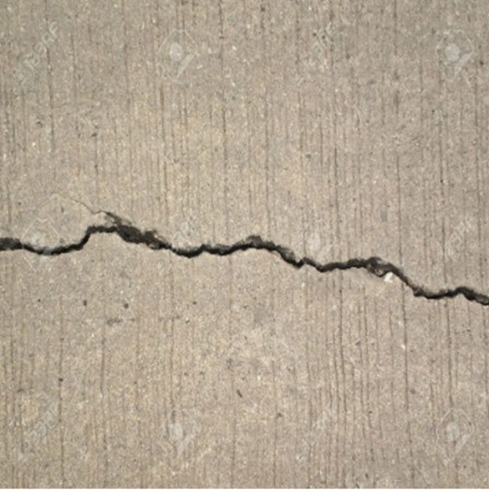

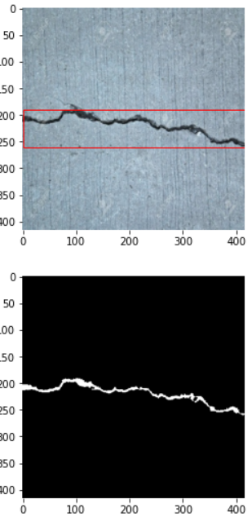

1. noncrack_noncrack_concrete_wall_55_24.jpg.jpg

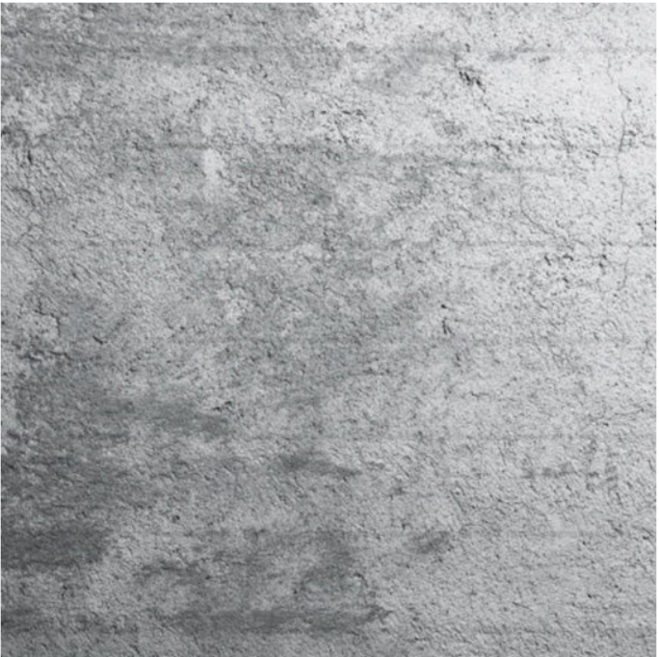

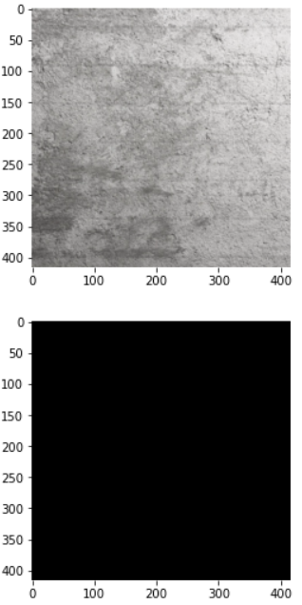

1. noncrack_noncrack_concrete_wall_7_0.jpg.jpg

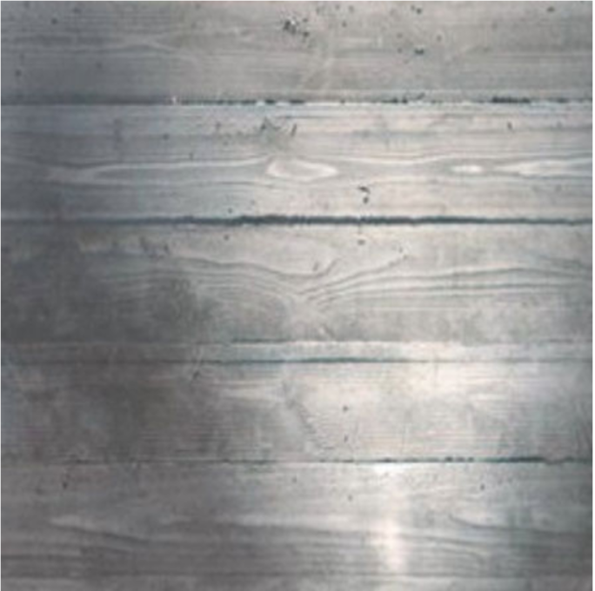

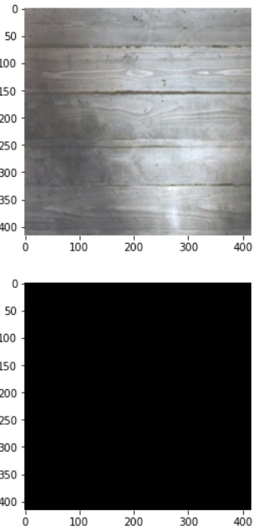

1. Rissbilder_for_Florian_9S6A3133_207_186_4184_3281.jpg- confidence = 0.34

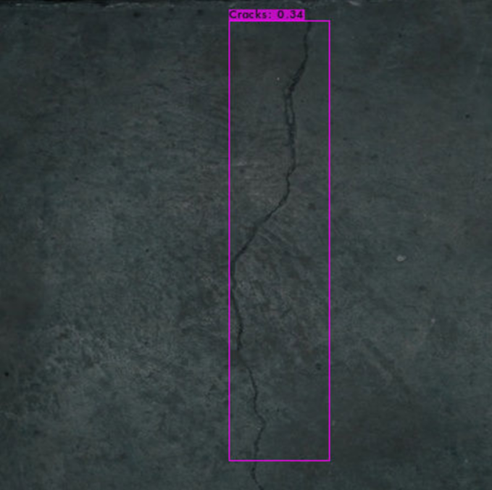

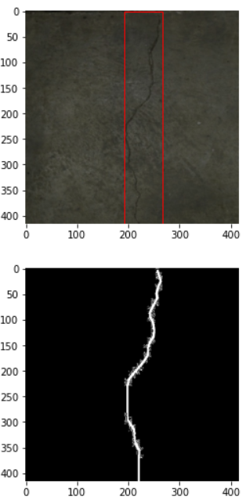

1. Volker_DSC01709_269_118_1281_1314.jpg- confidence = 0.97

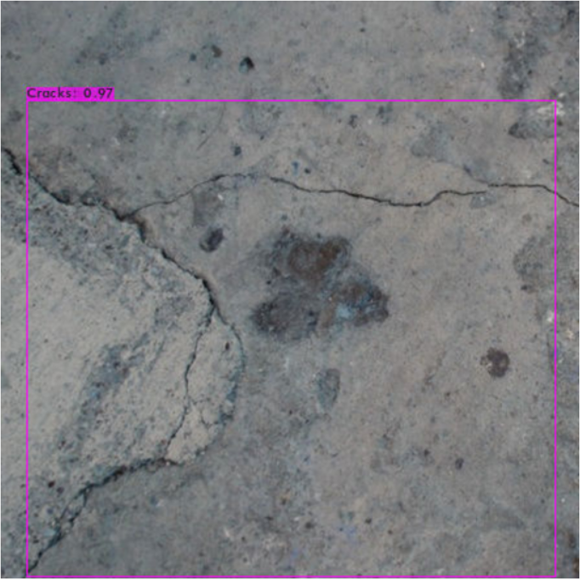

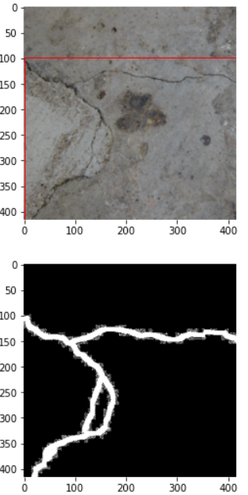

1. **CRACK500_20160222_080933_361_1.jpg- confidence = 0.74**

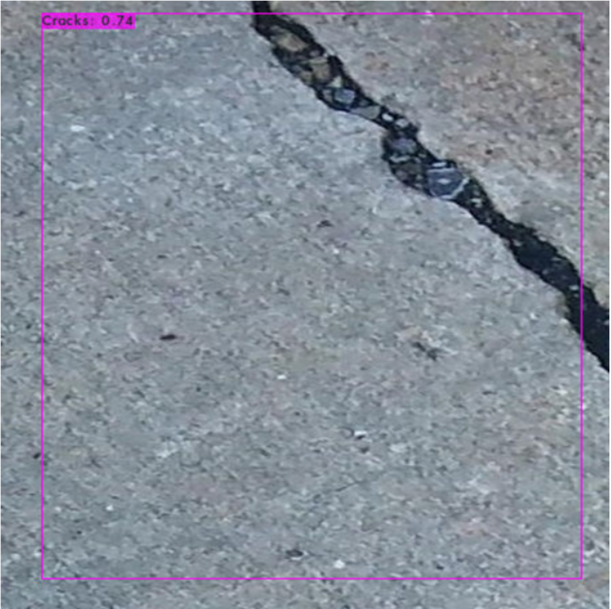

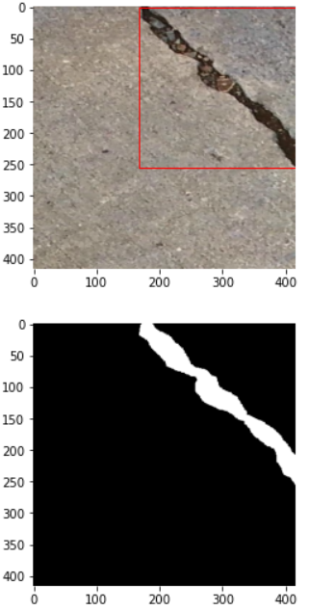

1. CFD_001.jpg- confidence = 0.36

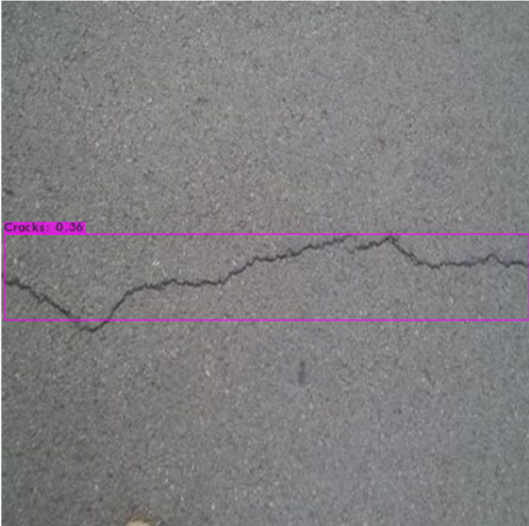

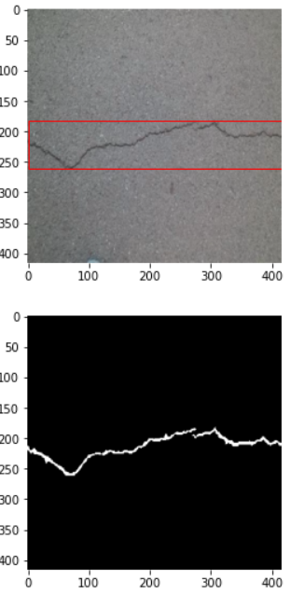

1. Cracktree200_6234.jpg- confidence = 0.96

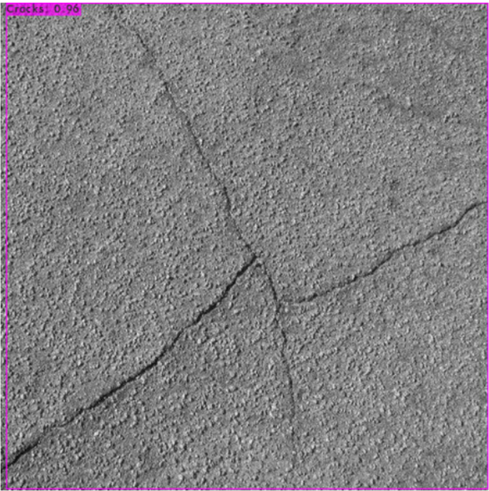

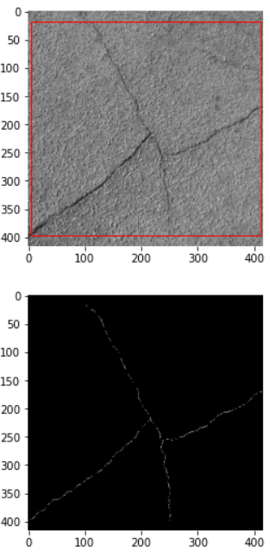

1. DeepCrack_11123.jpg- confidence = 1

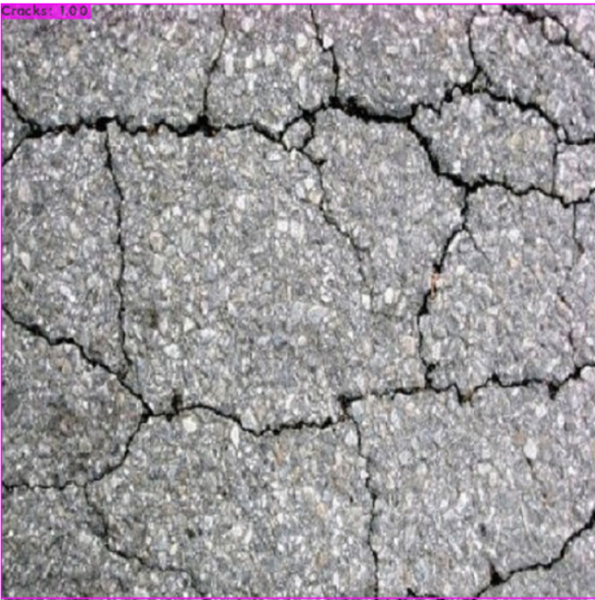

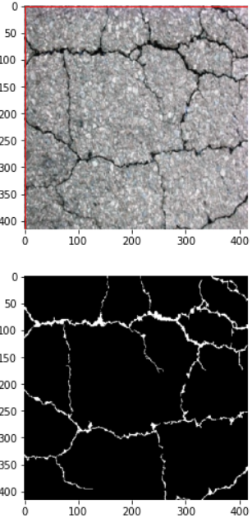

1. GAPS384_train_0542_1_641.jpg

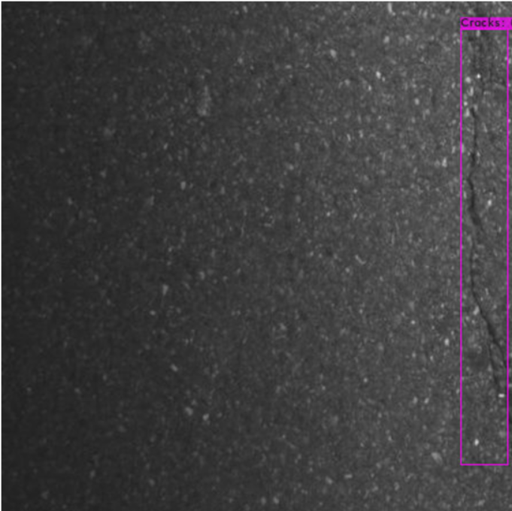

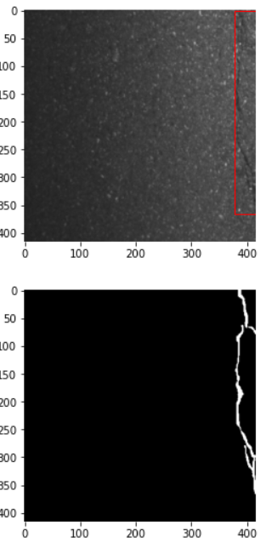

Loss at various epochs

3001: 0.327301

3050: 0.187258

3255: 0.196250

3293: 0.231648

3336: 0.182950

3351: 0.173026

3357: 0.167847

3935: 0.282261

3950: 0.275491

3965: 0.252552

3975: 0.232701

3990: 0.271027

4000: 0.231238